

CAREER AND ENTERPRISE DRAFT SAMPLE EXAMINATION

STAGE 2

Section 7 of the WACE Manual: 2008 Revised Edition outlines the policy on WACE examinations.

Further information about the WACE Examinations policy can be accessed from the Curriculum Council website at http://www.curriculum.wa.edu.au

The purpose for providing a sample examination is to provide teachers with an example of how the course will be examined. Further finetuning will be made to this sample in 2008 by the examination panel following consultation with teachers, measurement specialists and advice from the Assessment, Review and Moderation (ARM) panel.

2008/19222[3]





Western Australian Certificate of Education Draft Sample Examination

Question/Answer Booklet

CAREER AND ENTERPRISE
Please place your student identification label in this box
STAGE 2

Student Number: In figures

In words

Time allowed for this paper
Reading time before commencing work: Ten minutes
Working time for paper: Three hours

Material required/recommended for this paper

To be provided by the supervisor
This Question/Answer Booklet

To be provided by the candidate
Standard items: Pens, pencils, eraser, correction fluid, ruler, highlighter
Special items: Printed English language dictionary (non-electronic and not a thesaurus) Personal portfolio

Important note to candidates
No other items may be taken into the examination room. It is your responsibility to ensure that you do not have any unauthorised notes or other items of a non-personal nature in the examination room. If you have any unauthorised material with you, hand it to the supervisor before reading any further.
Structure of this paper

Section | Suggested working time | Number of questions available | Number of questions to be attempted | Marks available
Section One:  Short answer | 120 minutes | 7 | 7 | 60
Section Two:  Extended answer | 60 minutes | 2 | 2 | 40
 |  |  | [Total marks] | 100

Instructions to candidates

- The rules for the conduct of Curriculum Council examinations are detailed in the Student Information Handbook. Sitting this examination implies that you agree to abide by these rules.

- Write your answers in the Question/Answer Booklet using a blue or black ballpoint or ink pen. It is recommended that you do not use pencil.

- Spare answer pages may be found at the end of this booklet. If you need to use them, indicate in the original answer space where the answer is continued (i.e. give the page number).

SECTION ONE: SHORT ANSWER [60 marks]

In this section, there are SEVEN (7) questions. Answer ALL questions.

Suggested working time 120 minutes

Question 1

In his article in the West Australian Education Magazine (2007), Dr Peter Carey stated:

‘to survive and thrive in the world of work into the 21st century, people need to place an emphasis on flexibility, opportunity, enterprise, innovation, change, risk, being passionate about job aspirations’.

Choose any four (4) from Dr Carey’s list: flexibility, opportunity, enterprise, innovation, change, risk, being passionate about job aspirations and write them into the left hand column of the chart below.

Show how you are dealing with each of these important aspects of your career development by filling in the other columns
[4x3 marks]

EMPHASIS  (from the list above) | Explain the importance of this factor in SECURING work in the future  [1 mark] | Choose a piece of evidence from your portfolio which reflects a time when you demonstrated this factor and explain why you chose it  [1 mark] | How could you access learning opportunities to improve yourself in this area?  [1 mark]

Question 2
Assess networking as a career development tool. Identify a possible future career choice and describe at least two (2) opportunities for networking in this profession/industry area.
[4 marks]

Question 3
Workplace operations are based on effective communication systems.

- Choose two (2) traditional forms of workplace communication and explain how they are used in a workplace with which you are familiar.
[4 marks]

- Briefly explain how effective these traditional forms of communication are today.
[2 marks]

- Outline three advantages and three disadvantages of any two (2) new forms of communication technology, such as teleconferencing or electronic mail, for business/industry.
[6 marks]

Question 4
Consider the following information from the Australian Jobs 2007 website:

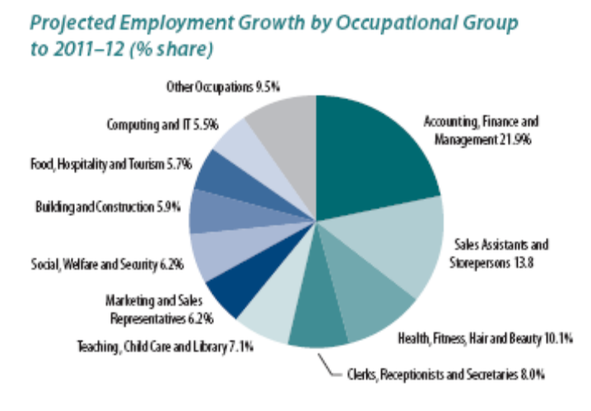
[Graph from: Department of Employment and Workplace Relations, 2007]

- Explain why it is important to consider this type of information, before making a decision about future employment.
[2 marks]

- Discuss whether the profession/industry area you are considering entering when you transition from education to the workforce is a growth area. How could this affect your future career opportunities?
[3 marks]

- State two (2) factors which could affect the accuracy of predictions such as these.
[2 marks]

Question 5
Conflict in the workplace is no fun and it can be even worse in a small or medium-sized business where there is no where to hide.

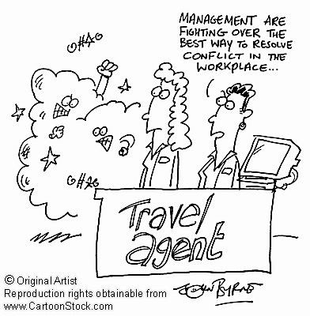

- Identify two (2) basic mistakes being made by management in the workplace shown in the cartoon.
[4 marks]

- Outline the services offered by an organisation or website which assists with conflict resolution in the workplace.
[4 marks]

______________

Question 6
- Discuss how you could use the following in your future work searches:

(i) Face-to-face/verbal communication
[2 marks]

(ii) Strategies in your local area
[2 marks]

(iii) Internet strategies
[2 marks]

- Identify a possible future industry area/profession in which you could work. Explain which of the above techniques/strategies you would be most comfortable using and which are most relevant to the chosen industry area/profession.
[3 marks]

Question 7
- Imagine you are advising a person entering the workforce for the first time about contracts. List four (4) essential elements that need to be included in any employment contract.
[2 marks]

- Some employers may try to take money out of your pay to cover for customers who leave without paying or if registers are short. Explain the employer’s rights and your rights in this situation.
[6 marks]

SECTION TWO: EXTENDED RESPONSE

In this section, there are TWO (2) questions. Answer BOTH questions.

Suggested working time 60 minutes [40 marks].

Question 8
Non-traditional business models seem to be the way of the future. Innovative labour and talent strategies are creating a network of patterns, settings and processes aimed at seizing a share of the global market place in which there will be a billion new consumers in the new decade.

- Outline five (5) innovative strategies which the Google Corporation has introduced to maintain the efficiency, productivity and sustainability of its workers.
[5 marks]

- Discuss the advantages and limitations of strategies such as those employed by Google and assess how successful you think the corporation has been with its innovations.
[5 marks]

- Describe three (3) management strategies used in workplaces.
[3 marks]

- Discuss which of the various management styles you prefer, including an example of a workplace in which you would be most comfortable and productive.
[7 marks]

Question 9
In 2007 toys were recalled from the Australian market after a number of health scares. Read the following information and answer the questions which follow:

‘Bindeez toys were recalled after children swallowed the beads and became ill, while concerns about lead levels in paint and powerful magnets forced the recall of Chinese-made Mattel toys in August. The major recall of the popular Bindeez beads was initiated when it was discovered the beads contained a toxic chemical that, when swallowed, had a similar effect to the date rape drug GHB.
CHOICE tested 30 toys that would appeal to the under-three age group and found 14 did not pass one or more of the safety tests and were a potential choking hazard under the Australian standard. The onus was on manufacturers and distributors to ensure products met the standards. Under the standard, toys must not contain small parts that present a choking hazard, or produce any when subjected to tests designed to simulate normal use such as dropping, pressing or pulling.
[Adapted from: Australian Associated Press, 2007]

An Australian Productivity Commission report last year recommended a national protocol be adopted in relation to toy safety (Octomedia, 2007). Australia needs a single agency to replace the current mixture of national, state and territory regulations (CHOICE, 2007).
Zhang Shuhon, the head of the Chinese toy manufacturing company at the centre of the recall, committed suicide. It was reported that the paint was supplied by Mr Zhang’s best friend. Chinese companies have long supply chains, making it difficult to trace the exact origin of components, chemicals and food additives.
[Adapted from: Associated Press, 2007]

- Explain why you think Australia imports products such as toys, even when the country of origin may not have the same strict industry standards as our own. Should we import such goods? Consider legal, financial and ethical factors in your answer.
[10 marks]

- Choose a profession/industry area which is connected globally and describe how it is connected.
[5 marks]

- Could you see yourself working locally, but connected to an employer in another country by technology—or would you consider actually working in another country? Discuss these as future career options.
[5 marks]

ACKNOWLEDGEMENTS

SECTION ONE

Question 1 Extract from: Carey, P. (2007). [Career management article]. WA Education Magazine.

Question 4 Graph from: Department of Employment and Workplace Relations. (2007). Australian jobs 2007 (p. 21). Retrieved April, 2008, from http://www.workplace.gov.au/NR/rdonlyres/A59A5A66-A6C6-4512-ACC8-1006D9331812/0/DecAustralianJobs2007.pdf.

Question 5 Cartoon: John Byrne. Retrieved April, 2008, from CartoonStock website: http://www.cartoonstock.com/cartpreview.asp?imageref=jby0278.

SECTION TWO

Question 9 Extract 1
Adapted from: Australian Associated Press. (2007, November 20). Alarm as toys fail choke tests. Retrieved April, 2008, from The Age website: http://www.theage.com.au/news/national/alarm-as-toys-fail-choke-tests/2007/11/20/1195321732480.html.

Extract 2
Octomedia. (2007, November 20). Toys in Australian stores fail basic safety tests: Choice. Retrieved April, 2008, from Inside Retailing Online website: http://www.insideretailing.com.au/articles-page.aspx?articleType=ArticleView&articleId=1716.

CHOICE. (2007). Many toys fail basic safety standards tests. Retrieved April, 2008, from http://www.choice.com.au/viewPressRelease.aspx?id=106063&catId=100576&tid=100010&p=1.

Adapted from: Associated Press. (2007, August 14). China bans toymaker's exports. Retrieved April, 2008, from Herald Sun website: http://www.news.com.au/heraldsun/story/0,21985,22239249-663,00.html.
Published by the Curriculum Council of Western Australia
27 Walters Drive
OSBORNE PARK WA 6017

